**ASQ’S BIG GIG**

Visual Storybook

**What is a visual storybook?**

A visual storybook is a visual and written guide to assist you with your visit.

Visual storybooks are used to prepare a person for a new environment or situation. This can help reduce stress and anxiety.

This visual storybook provides information on how to access ASQ’s BIG GIG, what to expect when you arrive and who to ask for assistance.

**Who is the Australian String Quartet?**

The Australian String Quartet, often shortened to ASQ, are an Australian arts organisation that focuses on playing string quartet music to audiences in Australia and around the world. The quartet is made up of four musicians, two playing violin, one playing viola and one playing cello. They are the Quartet-in-Residence at the University of Adelaide’s Elder Conservatorium of Music. Along with performing live they have recorded music as well available to listen to online. This year is their 40th anniversary since they began in 1985.

**ASQ’s BIG GIG**

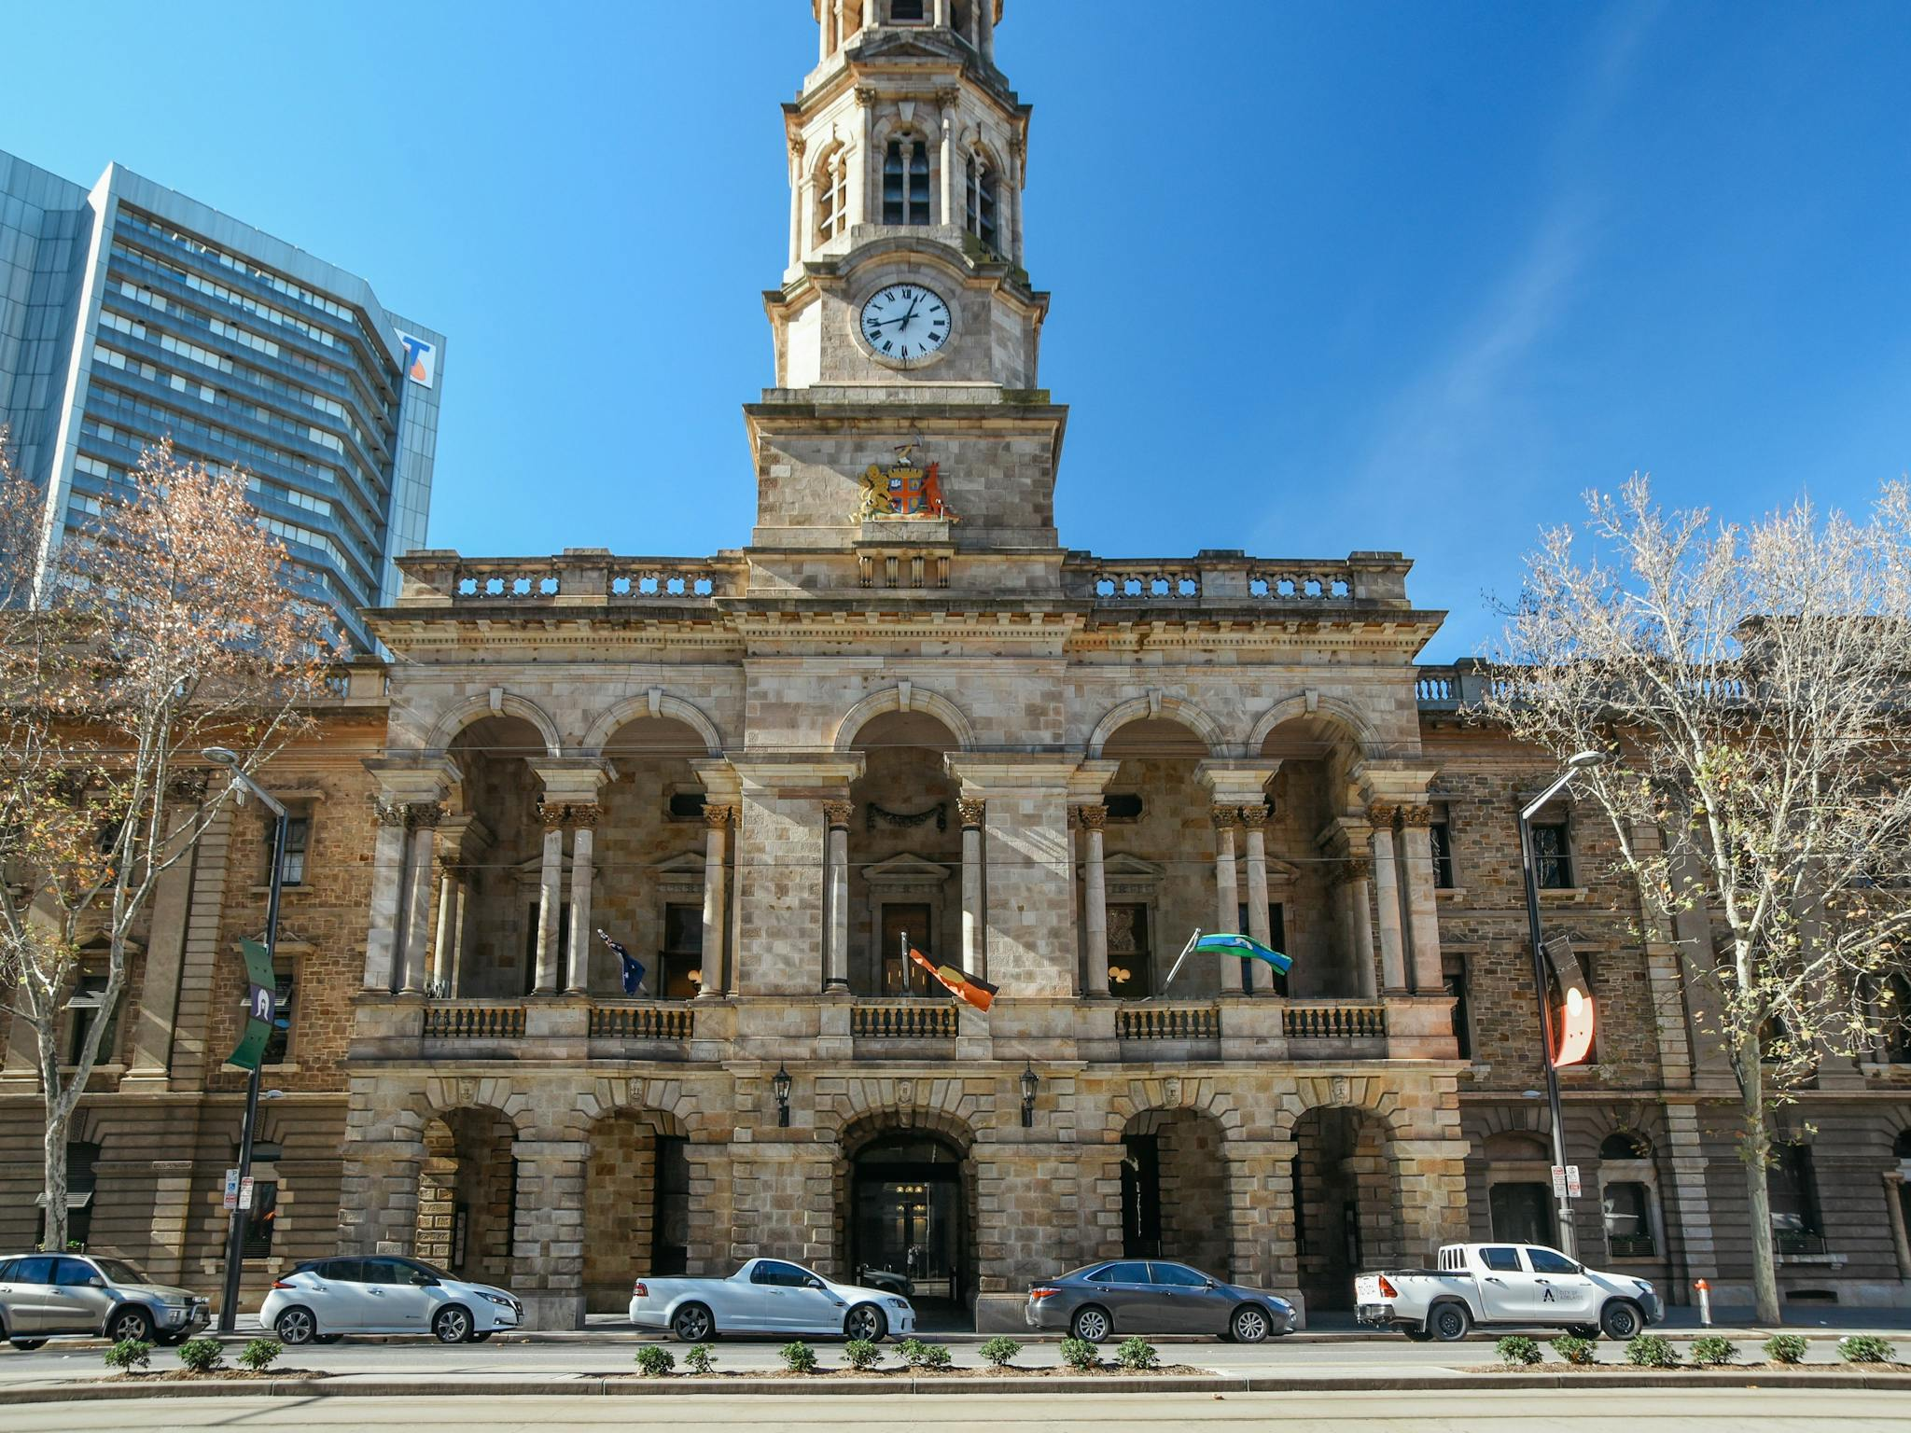

The BIG GIG will be at the Adelaide Town Hall on Sunday 28th September 2025.

Bookings for the ASQ concerts in the auditorium are required, as places are limited.

There are 3 ASQ concerts:

* Concert 1 starts at 1:30pm (relaxed performance)
* Concert 2 starts at 4:00pm (relaxed performance)
* Concert 3 starts at 6:30pm

**Tickets for ASQ’s BIG GIG**

The picture above shows an example of a ticket for ASQ’s Big Gig Concert 1. It has the concert title on top, then the venue name and which room the concert will be held in. These are Adelaide Town Hall in the Auditorium. Below that is the address for the Adelaide Town Hall. It then shows the date and time for the concert. The next line shows General Admission Ticket when means the seating type. In general admission and you can sit wherever you wish. On the right-hand side is the logo for the Australian String Quartet (ASQ) and a QR code used to confirm the ticket holder’s information. It then shows the ticket type booked; in this case it’s an Adult (27+ years).

Before you leave home, bring along a copy of your ticket. It can be stored on your personal device such as a mobile phone or printed on paper.

Your ticket will show you the concert time. You can come earlier to enjoy some free activities including:

* Performances by young quartets
* Trying a string instrument (Come and Try)
* Trying the VR (Virtual Reality) experience
* Looking at exhibitions about ASQ history with pictures and objects

**How to get to ASQ’s BIG GIG**

To get to the Adelaide Town Hall, you might go in a car, on a bus or on the tram.

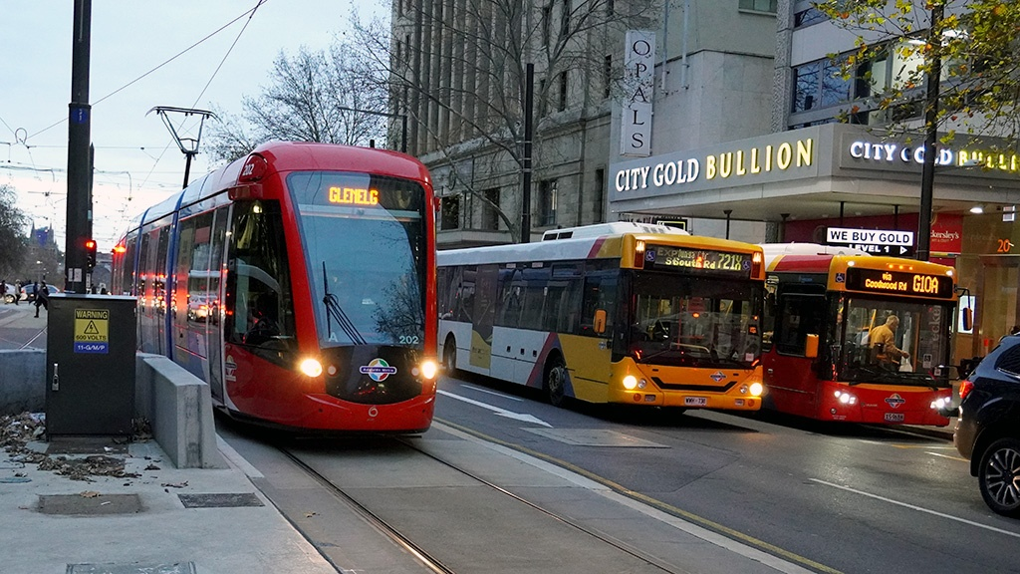

The closest car park is UPark Topham Mall.

There is limited accessible car parking and accessible drop off area available in front of the Adelaide Town Hall on King William Street.

**At the Venue**

When you get to the Adelaide Town Hall, you will go through the glass door to the inside area, which is called a foyer.

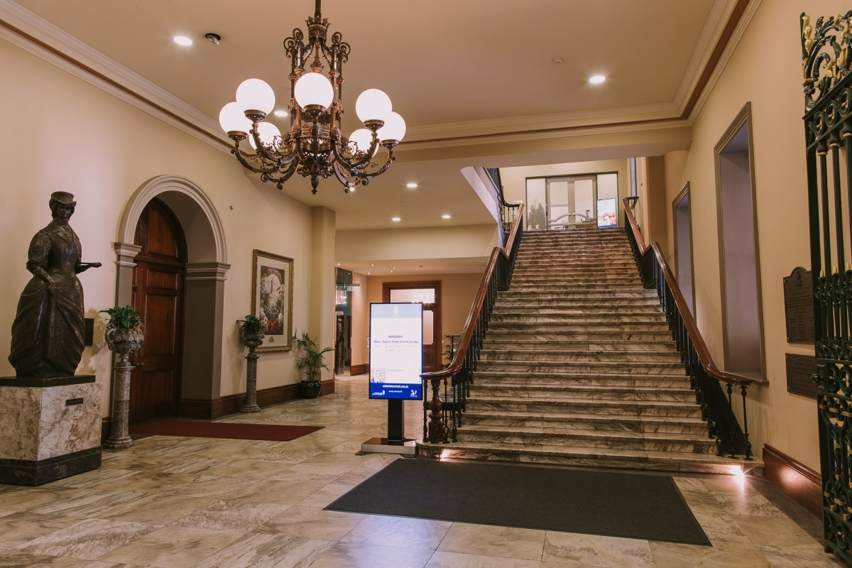

There will be a person at a desk called the “Box Office”. You can ask this person for any assistance.

If you already have your concert ticket, you can go up the stairs on the right or get the lift to level two (2).

If you do not have a ticket, and would like one, you can book a free ticket with the person at the desk.

You can get a program of the activities Box Office, which will tell you what time each activity is on.

There will be lots of different people coming to watch the concert, participate in activities, and look at the exhibitions.

You might have to wait to talk to someone, participate in the Come and Try sessions or virtual reality, or to use the toilet.

There are two areas where accessible unisex toilets are located on level 2 in the Adelaide Town Hall. First is at the end of the main foyer. The other is opposite the Banqueting Room.

**Food**

There are some food options available for purchase on the day.

Donuts and coffee will be available for purchase on the day along with beer, wine, sparkling wine, soft drink and water.

The Adelaide Town Hall is a Cashless Venue. This means they only accept EFTPOS payment. This can be made through a debit or credit card or through a digital card on a mobile phone.

**Activities**

You can choose to look at the exhibitions, try the virtual reality, or hold an instrument.

There will be signs that show where to go.

It is okay to watch these activities if you don’t want to try yourself. You can also watch some performances young local musicians.

**Exhibitions**

There will be some big black panels with some things to look at on them.

You might see some old photos of musicians or a poster from a long time ago.

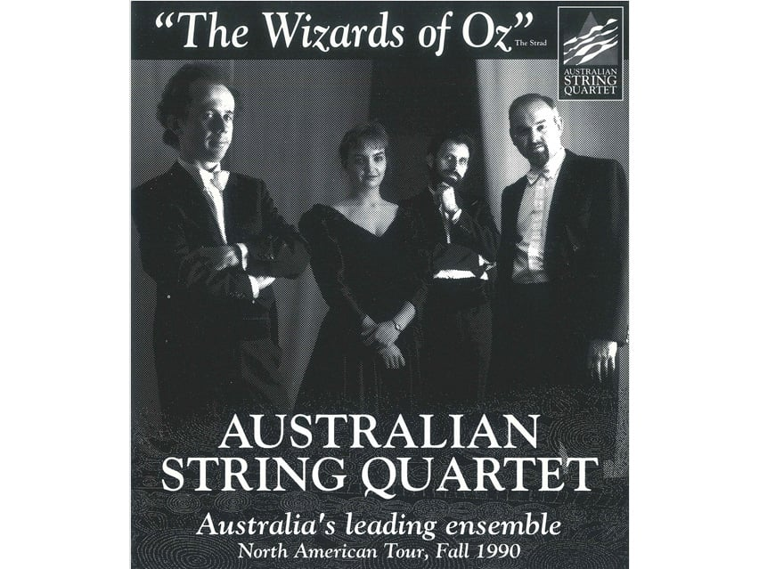

**Come and Try Sessions**

You might like to have a turn at holding some instruments in the Prince Alfred Room.

Other people will have a turn too, so you might have to wait to have a go.

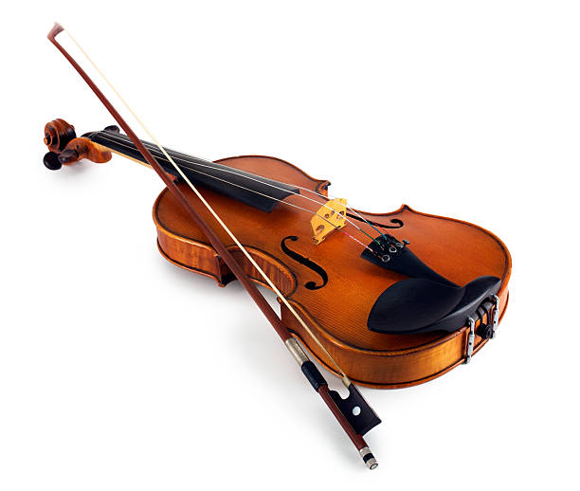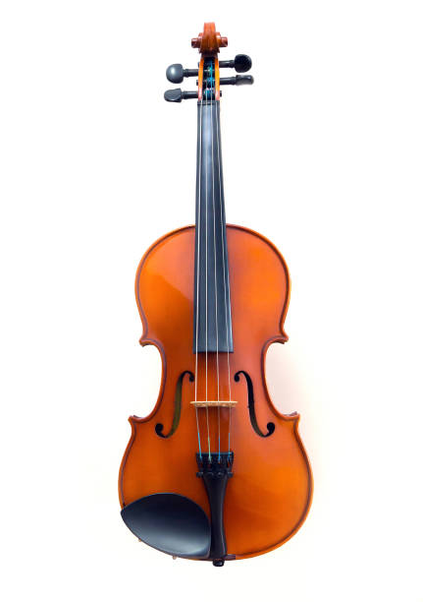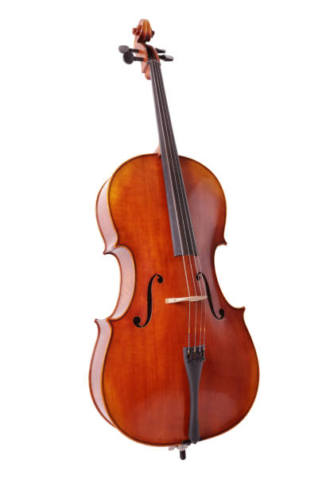

**Square Circles Virtual Reality (VR)**

Square Circles VR is like a 3D film which can be viewed on special headsets.

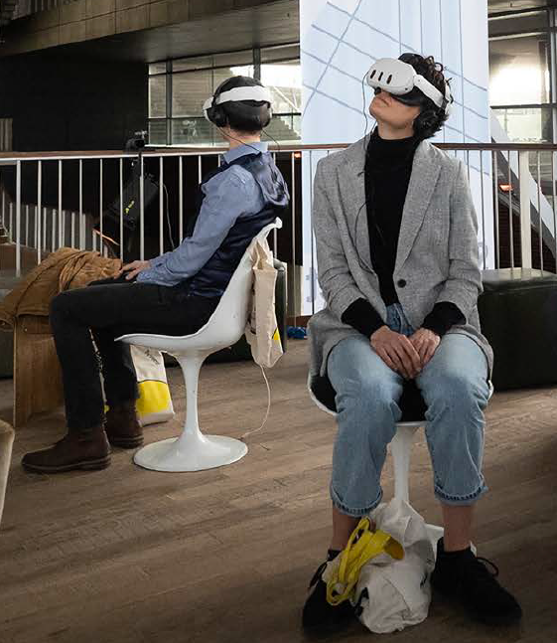

You will need to sit down and put the headset over your eyes and headphones on your ears if you want to look at/listen to the VR.

When you have the headset on you will see some interesting landscapes that have been made by computer and hear the music of William Barton and the ASQ.



There are bright lights and loud sounds. If you don’t like these you don’t have to try the VR.

**ASQ Concerts in the Auditorium**

The doors to the Auditorium will open 15 minutes before the performance. You may need to wait to enter.

Concert 1 and Concert 2 will be relaxed performances. This means:

* The lights will be kept on at a low level
* You can move around, make noise or vocalise as you need without judgement
* You can enter or exit the performance space if you want to
* You can choose to sit on the cushions or rugs or in a seat

The concerts will go for 60 minutes.

You will need to show your ticket on the door. If you need any assistance the event staff can help.

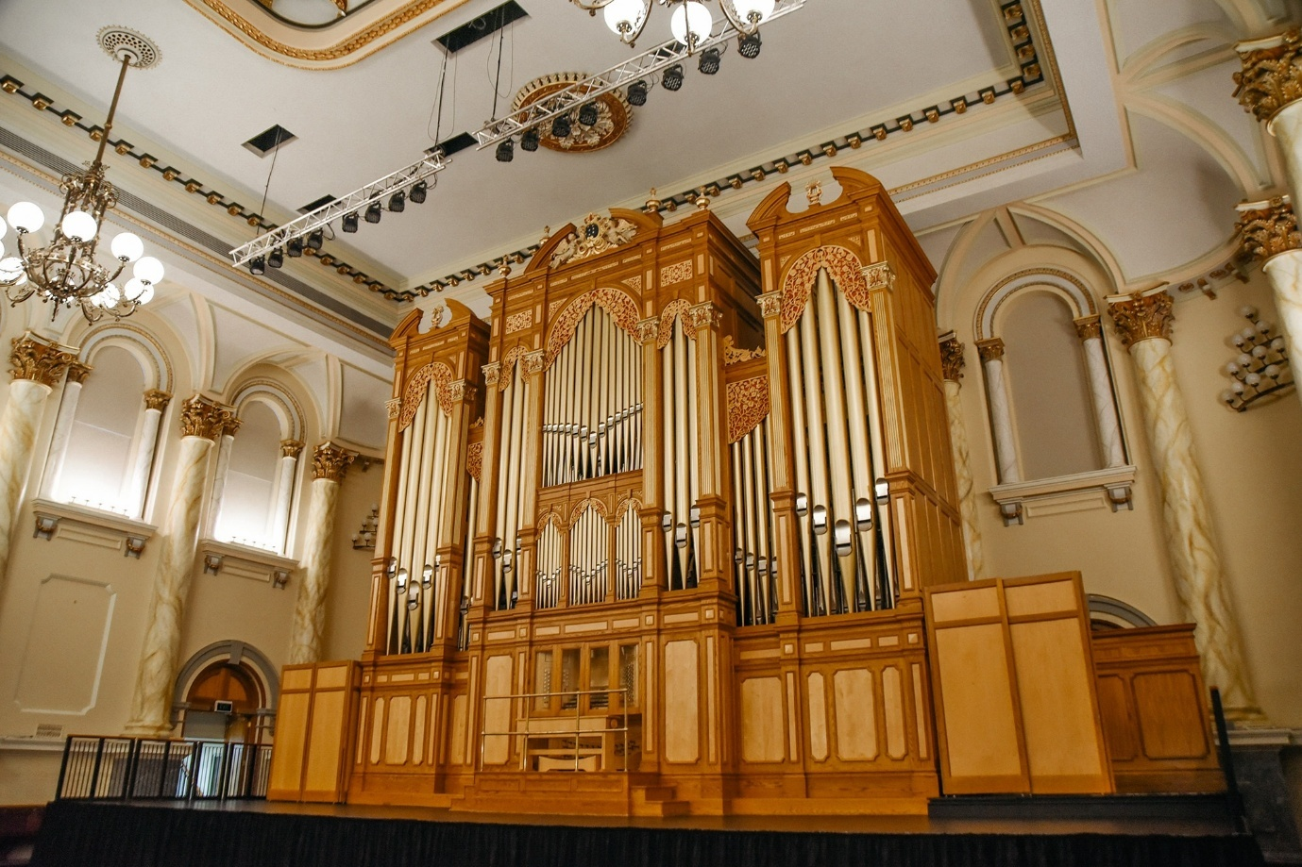

The stage will be set up in the middle of the room with music stands and chairs for the Quartet.

There is a big organ which you can look at.

You can choose where to sit, there is no reserved seating. Everyone else will choose where they will sit.

Once everyone is sitting down, the Quartet will enter and walk up to the stage. People will clap. You can clap too.

The Quartet are like a band with four people.

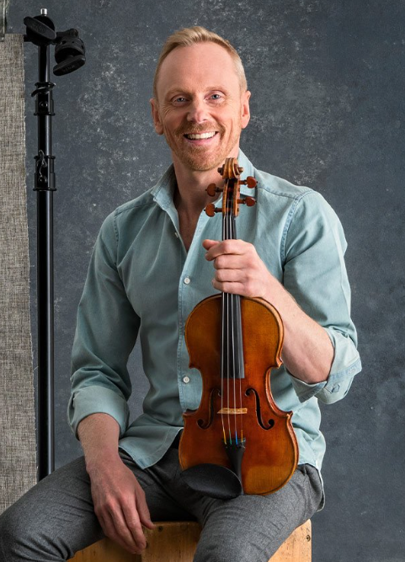

Dale and Francesca play the violin.

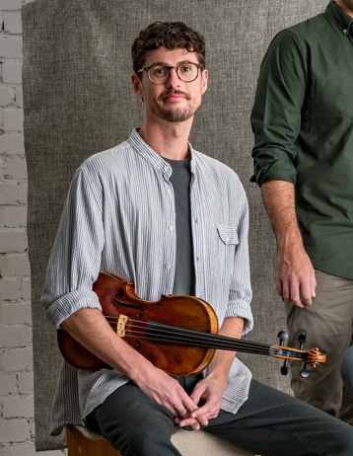

Chris plays a viola, which is a bit bigger than a violin.

Michael plays a cello which is the biggest instrument.

The Quartet will talk to the audience about the music during the concert.

They might talk about the composer, which is who wrote the music. They might also talk about how the music makes them feel.

Some of the music might be loud, fast or it could be quiet and slow.

The Quartet will stand up at the end of the concert. You can clap your hands to say thank you. Others will clap too.

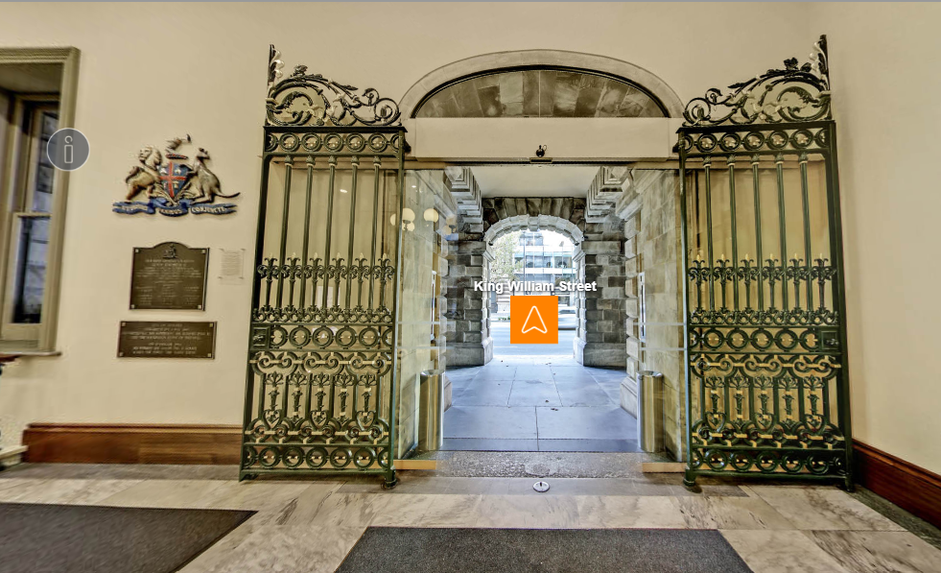

When the concert is over, you can leave the Auditorium and the Town Hall. Everyone else will be leaving, too. It might be crowded, and you may need to wait to get outside.

If you want to have another look at the exhibitions before you go, you can. More people may be arriving if there is another concert after the one you are attending.

If you have any questions you can call the ASQ on

1800 040 444 or you can email [asq@asq.com.au](mailto:asq@asq.com.au)